Lab No. 11
Lab Tasks:
- Step 1 to 3: Import Libraries, Generate Data, and Create DataFrame
We'll import the essential libraries (pandas, nltk, sklearn) and create a balanced dataset of product reviews to simulate online data
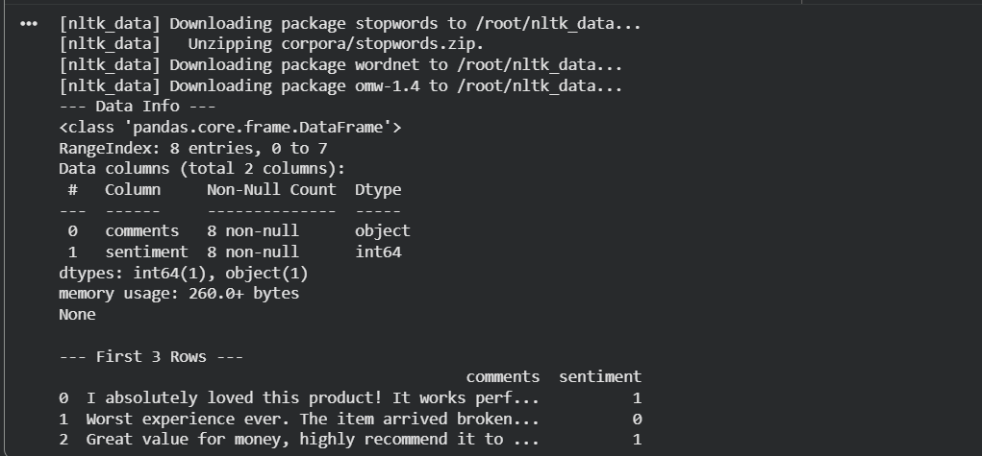

Step 4: Check if the Dataset is Balanced
We check the distribution of classes to ensure our classification model isn't biased.
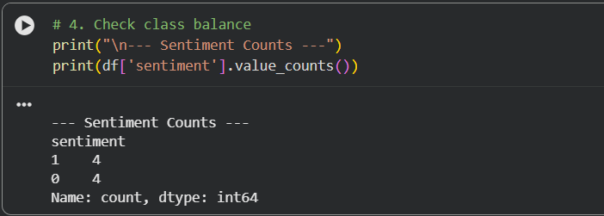

Step 5: Essential Preprocessing Functions
We will create a dedicated preprocessing function to handle duplicates, missing values, whitespaces, digit removal, case normalization, and stemming/lemmatization.
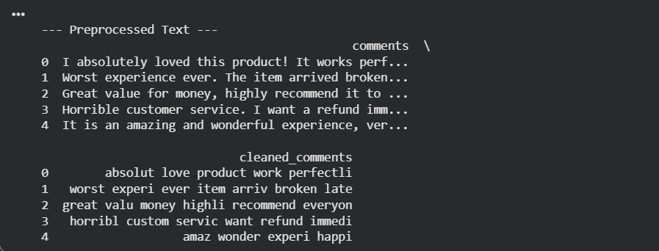

Step 6: Construct Training and Testing Datasets
Split the data into training (e.g., 75%) and testing (e.g., 25%) sets.
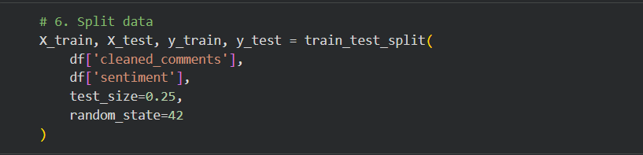

Step 7 to 9: Feature Extraction Using BOW (Approach 1)
Here, we build the Bag of Words (BOW) model using CountVectorizer. This builds a unique word dictionary and creates Document-Term Matrices (DTM).
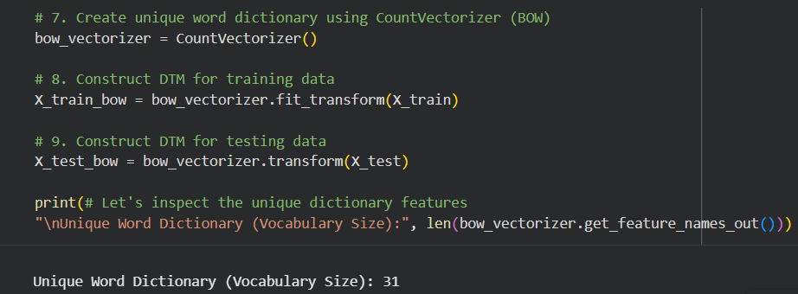

Step 10 & 11: Build and Test the BOW Sentiment Model
We will use a Naive Bayes classifier (MultinomialNB), which is ideal for text classification.
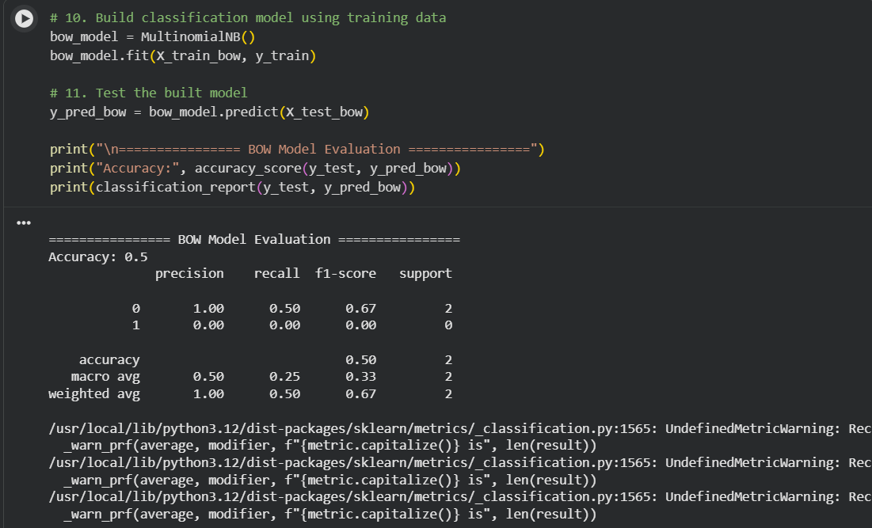

Implement Weighted Term Feature Model & Compare
Now, we develop a parallel model using Weighted Term Feature Extraction (TF-IDF) and record the comparison.
